**Group *3***: - Report *4*

**CSE523 Machine Learning**

**Heart Attack Prediction**

|  |  |
| --- | --- |
| **Group Members** | **Roll No** |
| **Shivam Thakker** | **AU1940193** |
| **Devarsh Sheth** | **AU1940189** |
| **Pranav Gandhi** | **AU1940313** |
| **Meet Jhaveri** | **AU1940284** |

* After dividing the data into train and test set and applying the KNN model, the next thing which we have done was applied two other models to our data.
* The two other models which were applied where logistic regression and Linear Discriminant Analysis (LDA).

Logistic Regression.

* Here we have used an inbuilt function which is logisticRegression to predict the heart attack.
* First of all, we fit the model and then test the model.
* The accuracy which we were getting in this case was 90%.

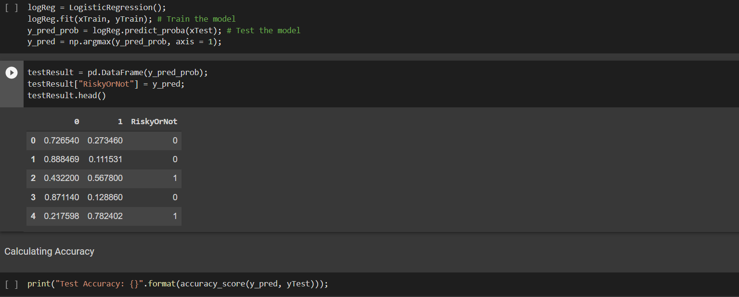

* The reason behind this is logistic regression performs well where we are having a binary output.

Linear Discriminant Analysis:

* Then after we use LDA model to predict the heart attack.

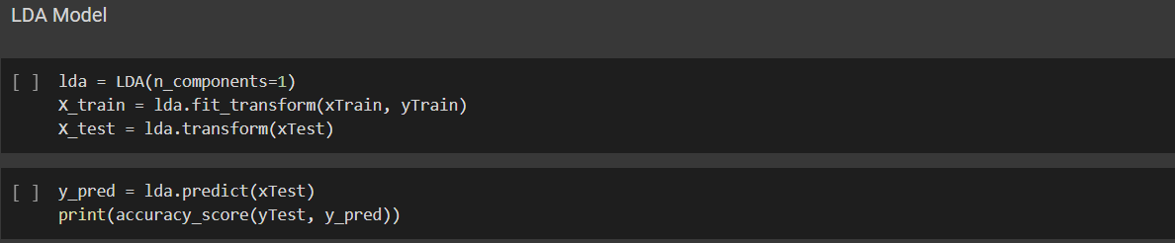

* The accuracy in this case was 87%.

Thank You